Validation of ANSYS Workbench using Digital Image Correlation with ARAMIS Jennifer Borshoff

Abstract
The Sibley School of Mechanical Engineering at Cornell University runs an experiment with aluminum bike cranks in which students load four different crank geometries with 100 pounds of force, and strains are measured with strain gauges. The students then simulate the experiment in ANSYS Workbench and compare the results of simulated strain gauges with those of the physical gauges. Further validation of the procedure for simulated strain gauges in ANSYS was desired. To validate the ANSYS Workbench procedure and strain gauge values, the same experiment was run using digital image correlation with ARAMIS to collect strain field values. Strain gauge values and strain field contours from the ARAMIS were compared to ANSYS simulation solutions.

Geometries of the four cranks can be found in Appendix A.

Initial Procedure
ARAMIS
The four bike cranks were supplied by Cornell University. Each was machined out of Aluminum 6061 T6 with a Young's Modulus E = 10,000 Ksi and a Poisson's Ratio v = .34. Each crank had two discrepancies from the provided drawings. All four contained two extra holes directly above and below the pin hole on the "Crank End" of the bicycle cranks, and the region of the crank behind the hole on the "Pedal End" is cut out. Along with the cranks, the university supplied the testing frame used for the experiment. Each crank is fixed in place by pinning its "Crank End" through its three holes on the right hand side of the frame. The loading is applied with a single pin through the "Pedal End" of the crank with a flattened nut filling in the cut out section. The pin is attached to a load cell, and a turn-buckle is used to apply the force.
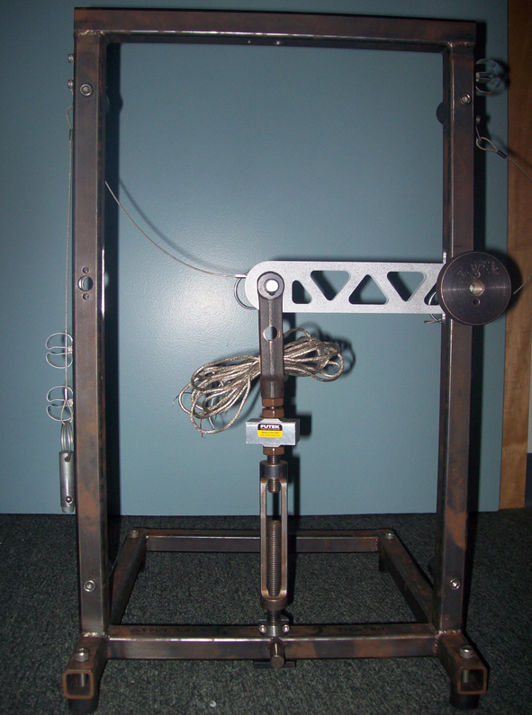

Before loading, the cranks were prepared for the digital image correlation by adding the speckled pattern which the ARAMIS software tracks. First the cranks were coated with a layer of white spray paint for contrast, and then a mist of black spray paint was applied to give the cranks the speckles. The painted cranks were each fixed in the frame and loaded in ten pound increments, using the turn-buckle, up to the full one-hundred pound force. A picture was taken with ARAMIS after each load increment.

The boundary conditions cause the loading to be similar to a cantilever beam loading, with bending in the XY-plane, so the greatest strains lay in the X-direction. Therefore, the result that was of most interest was the X-Strain field for each crank. To reduce the amount of noise in the strain fields, the images were smoothed in ARAMIS. The smoothing is a moving average applied across a specified number of facets, and implemented a certain number of times.

ANSYS Workbench
The CAD models of the bike cranks were supplied by Cornell University. Each model was modified in Solidworks in order to match the geometry of the physical cranks as well as possible. The two smaller holes on the crank end where the physical cranks are pinned into the frame were added; however, the cut out section behind the "Pedal End" hole was not able to replicated. The modified CAD models were input into ANSYS Workbench where a static structural analysis was used. The boundary conditions applied were a Fixed Support along the inside faces of the three holes on the "Crank End", and a 100 lbf force in the negative Y direction, downward, applied to the inside of the hole on the "Pedal End" of the cranks. In each simulation the material was defined as Al 6061 T6 with Isotropic Elasticity. The aluminum bike cranks stayed in the elastic strain range for the entirety of the tests, so only Young's Modulus and Poisson's Ratio were necessary for material constants. The simulation was solved and a Normal Strain solution, applied in the X-direction on the face of crank, was output for comparison to the ARAMIS X-strain fields.

As part of the validation for ANSYS, different element sizes were tested starting with elements of a .2 inch length and decreasing until the elements had a .05 inch length. The strain field contours of each crank remained very similar throughout the element size testing, and by .05 inch elements the maximum and minimum values had leveled off to the values seen in the result section.

Initial Procedure Results
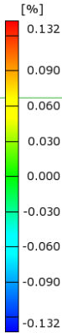
X-Strain Contours with ARAMIS contours scaled to match ANSYS.
All contours shown with full 100 lbf applied.

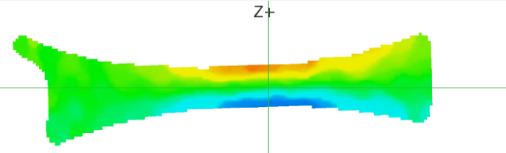

Crank 1 ARAMIS X-Strain Field, Turn-Buckle Loading

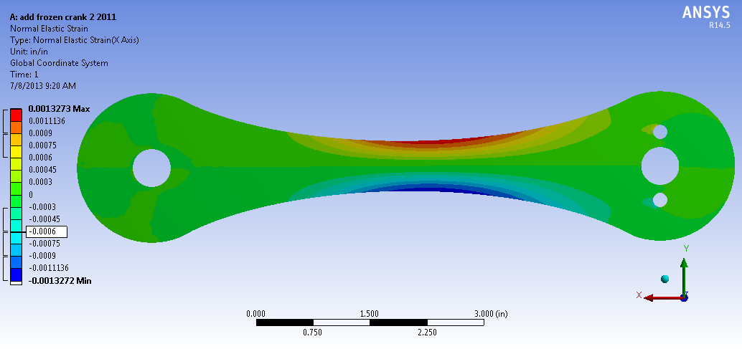

Crank 1 ANSYS X-Strain Field

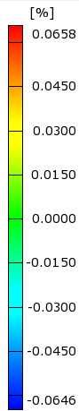
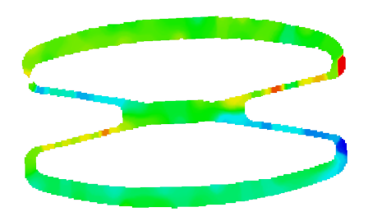

Crank 2 ARAMIS X-Strain Field, Turn-Buckle Loading

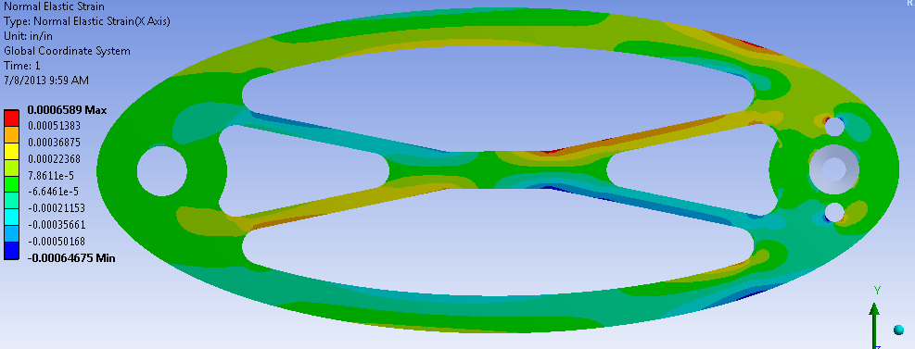

Crank 2 ANSYS X-Strain Field, Turn-Buckle Loading

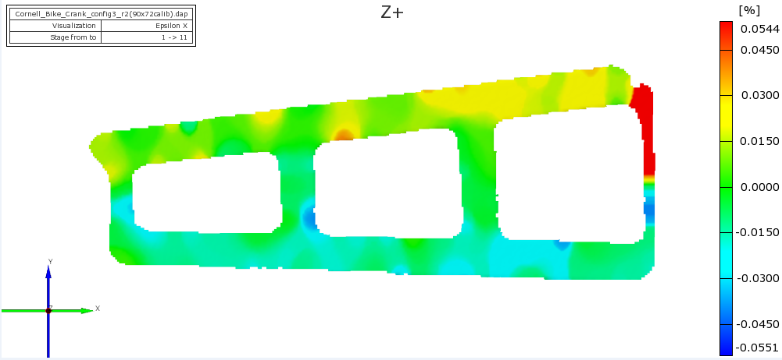

Crank 3 ARAMIS X-Strain Field, Turn-Buckle Loading

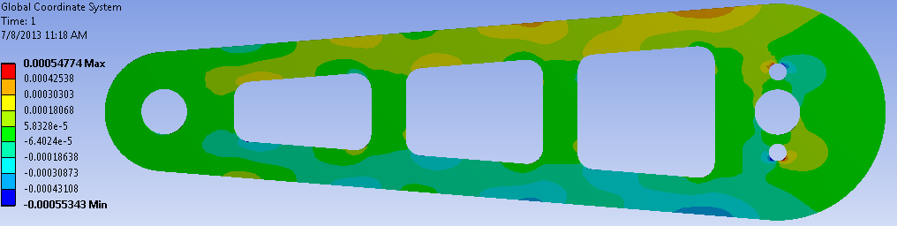

Crank 3 ANSYS X-Strain Field

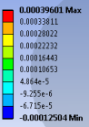
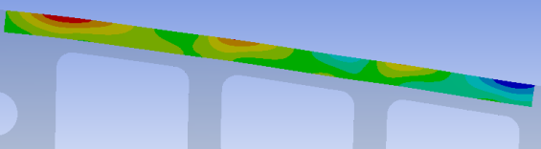

Crank 3 ANSYS Contour Details, Compression on Top Edge

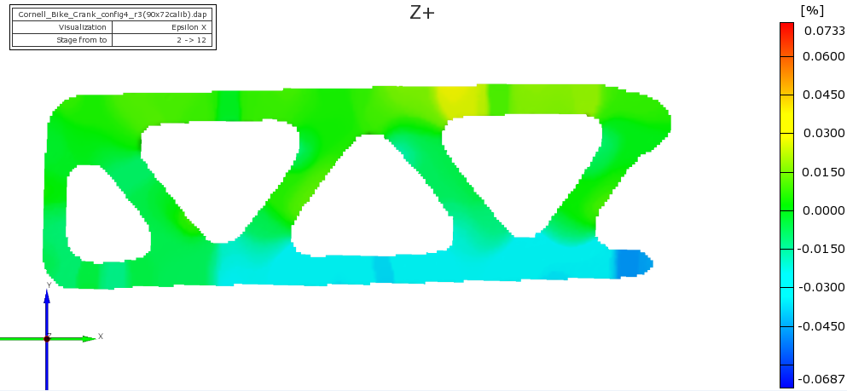

Crank 4 ARAMIS X-Strain Field, Turn-Buckle Loading

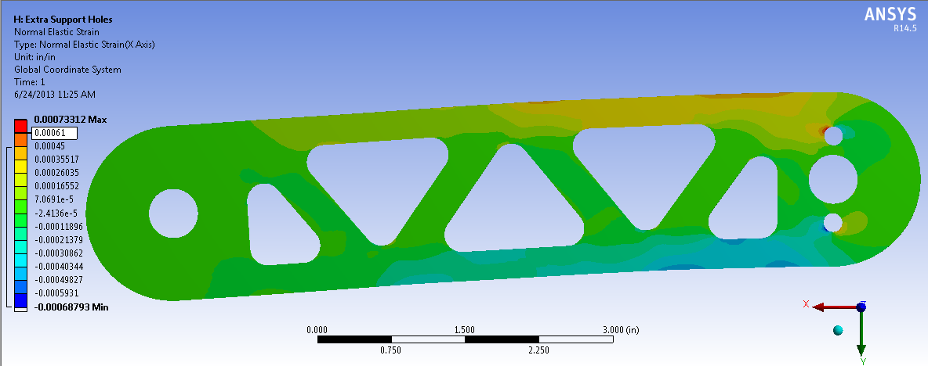

Crank 4 ANSYS X-Strain Field

Initial Procedure Analysis
The X-Strain fields obtained from the ANSYS simulations showed a decent correlation to the first ARAMIS test with the turn-buckle loading. All of ANSYS' strain fields showed the same contour banding as ARAMIS and had a very similar range in values.

Crank One:
ANSYS also correctly predicts that the regions with the highest strain magnitude are to the right of the center and not at the region with the smallest cross section. This non-symmetric behavior is caused by the ratio between the bending moment and the area of the crank's cross section. The regions closer to the fixed end of the crank have larger internal moments, but the height of the crank, and therefore the cross sectional area, also increases towards the fixed end. The axial stress is computed from sigma_X=(My)/I, with I = (1/12)*b*h^3, and the axial strain is calculated from sigma_X/E, with E constant. For this reason, the maximum strain occurs when M/h^3 is maximized. ANSYS correctly predicts and interprets this dependency.

Crank Two:
The contours do not match quite as well for this crank, although the general regions of tension and compression are the same. One consideration is the small width of the crossbars. The small widths forced the use of a small facet (2D element) size for the ARAMIS analysis of the crank, but smaller facet sizes cause greater the noise levels in the strain field. For this reason, it was necessary to apply more smoothing to the ARAMIS image to obtain a noise-free strain field, but due to the smoothing the concentrated regions are not as pronounced.

Crank 3:
The ANSYS strain field shows the same regions of higher concentrated strain as on the ARAMIS and shows similar magnitudes in these regions. Unexpectedly, though, ANSYS shows two regions of compression along the top edge of the crank. This is magnified by showing the contour of only the top edge of the crank. This unusual compression may be caused by the boundary conditions used in ANSYS. In the experimental set up the crank can rotate under the pin. This allows the crank to be in a state of pure bending with the ability to rotate around the Y-axis. The load applied in ANSYS does not contain this extra degree of freedom, though, so the crank's "Pedal End" is forced directly downward without the ability to rotate. The inability to rotate forces the end of the crank to remain in line with the X-axis while the rest of the crank bends downward, thus creating a region of compression on the top of the crank where these sections meet.

Crank 4:
ANSYS and ARAMIS show the same general pattern within the contours; though, the details are lacking. Both ANSYS and ARAMIS predict almost zero strain throughout the diagonal members; however, ANSYS shows higher regions of strain along the top and bottom edges than ARAMIS.

The ARAMIS' range of view is much smaller than that of ANSYS, so ARAMIS does not show the strain around the fixed or loaded holes of any of the cranks. In all but crank one, the holes are where ANSYS predicted the largest magnitudes of strain. To accurately compare results, the same regions should be compared. Also, it was noticed that the turn-buckle allows for a large range of movement in the Z-direction while the cranks are being loaded which may contribute to the noise in the ARAMIS strain fields. In order to reduce these discrepancies, a second test was done using an Instron to load the cranks, and the ANSYS simulations were modified to contain a more accurate representation of the experiment. More definite values of strain with strain gauges were also desired for comparison.

Another consideration is the facet size used in the ARAMIS. As a best case scenario for directly comparing the results of the ANSYS simulations to ARAMIS, the facet size of ARAMIS will match the element size of ANSYS. However, at least a small amount of smoothing is necessary across all of the ARAMIS strain fields. ARAMIS smoothes the images using a moving average; therefore, after smoothing it is as if the ARAMIS had used a larger facet size. The relationship between the original facet size and the averaged facet size after smoothing was not able to be calculated, though, so it was decided that the ARAMIS would be left so that there were the same number of original facets as there were elements in ANSYS.

Secondary Procedure
ARAMIS
The testing set up was the same with the exception of the loading mechanism. The speckle-painted cranks were pinned in place on the frame, and the frame was placed in an Instron. The load cell was included in the set up for verification of the force applied. The Instron was used to apply a downward force on the loading pin at a constant rate to 100 lbf while ARAMIS took pictures at about half pound increments.

The ARAMIS solutions were also used to find local strains, similar to the way that a strain gauge would. With ARAMIS, strain gauges can be created using small areas or lines drawn on the calculated strain field. Crank one was chosen to use for most of the strain gauging. Crank one had the best correlation of strain field contours and the least amount of noise, most likely due to the simple geometry of the crank. Two points were chosen in regions where high magnitudes of strain were shown in the X-Strain field, one in tension and one in compression. Area strain gauges of size 2mm by 2mm were used to find both the X and Y strains at these points. Two other points in areas of high strain were also chosen and line strain gauges were applied here. For further comparison in strain gauging, one point was chosen on crank four, in a region of high positive strain, and an area strain gauge was used. Diagrams of the placement of the area gauges can be seen in Appendix B.

ANSYS Workbench
All further ANSYS simulations used a .05 inch mesh.

In order to provide a more accurate boundary condition where the crank had the ability to rotate, the model was updated to include the loading pin. Contact was specified between the crank's loading hole and the pin, and the 100 lbf was applied to the pin which then translated the force to the crank. The new X-Strain field contours for the contact were output and compared to the previous X-Strain fields.

In order to directly compare the ANSYS strain fields to the ARAMIS results, the strain concentrations around the fixed holes in the ANSYS simulations needed to be removed. To do this, overlays of the middle section cranks two, three, and four were created in Solidworks. Crank one's largest strains were not concentrated around the fixed holes, so no overlay was created. Each overlay had zero thickness and were mated to the solid crank CAD model, and then loaded into ANSYS Workbench. This allowed the strain field in only the overlay section to be viewed when the overlay was scoped for a Normal Strain solution.

Strain gauging in ANSYS Workbench was done two ways, with line strain gauges and area strain gauges. Area gauges of the same size as those in ARAMIS were mapped to the same points on the CAD model as they had been placed on the ARAMIS strain field. Paths were drawn in the same positions that line strain gauges had been used in ARAMIS with matching lengths.

For a line strain gauge, a path defined along the surface of the crank was scoped with a Normal Strain solution, and the discrete strain values of the points on the path were averaged for a final strain. For an area strain gauge, the gauges were created in Solidworks. Each gauge was made as a small rectangular surface with zero thickness which was mated to the surface of the crank in the desired position. When this geometry was imported into ANSYS Workbench, a small thickness for the gauge was specified in Mechanical. The gauge was set to have zero stiffness, and the gauge's mesh was overlaid onto the crank's mesh. This allowed the gauge to interpolate its solution from the underlying mesh of the crank without changing the solution.

Theoretical Strain Calculations
Theoretical strain gauge values were desired for a third point of comparison. However, due to the unusual geometries of the bicycle cranks, certain simplifying assumptions needed to be made for each crank in order to complete the calculations. With these assumptions in mind, the theoretical values exist only as benchmarks for the ARAMIS and ANSYS strain gauge values.

Crank one, the simplest geometry, was analyzed as if it were a cantilever beam with the same height and cross sectional area throughout. The height of the beam was assumed to be the height of the cross section at the point of interest on the crank. The circular ends of the crank were disregarded, so the length of the beam was assumed to be the same as the distance between the centers of the pinned hole and the loaded hole, 6.69 inches. The last assumptions made were that the face of the crank was in a plane stress condition and that sigma_y is so small compared to sigma_x that it can be taken to be zero. The calculations were then continued using basic beam theory. By completing a static analysis to find the moment and shear force at the cross section of the desired point, the axial stress at the cross section was computed. Using this axial stress with Hooke's Law in 3D, the strains in the X and Y directions were computed.

Axial Stress: sigma_x = My/I
Hooke's Law in 3D: | ε_x | = 1 | 1 -ν | | sigma_x |
| ε_y | E | -ν 1 | | sigma_y |

Crank two is the most complex of the bicycle cranks, and due to the curvatures of the members, so theoretical calculations were not done for this crank.

Cranks three and four were both analyzed as ideal truss structures. The members were modeled as mass-less bars, and the structures were fully fixed at the right hand end with the one hundred pound force acting on the left most member in the structure. Force balances were used at the intersection points of the members to find the axial force through each member. With all of the axial forces known, the normal stress through each member could be calculated, and Hooke's Law in 3D was then used to find the strains at the points of interest.
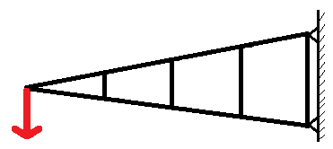
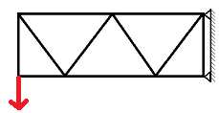

Crank Three Truss Structure Crank Four Truss Structure

Secondary Procedure Results
ANSYS Workbench: Simulation with Pin loading and Contact

Comparison of Minimum Strains between Face Loading and Pin Loading
( Micro-Strain)
 | Minimum with Original Face Loading | Minimum with Pin Loading | Percent Difference
Crank 1 | -1327 | -1311 | -1.21%
Crank 2 | -647 | -627 | -3.09%
Crank 3 | -553 | -561 | 1.50%
Crank 4 | -688 | -727 | 5.67%

Comparison of Maximum Strains between Face Loading and Pin Loading
( Micro-Strain)
 | Maximum with Original Face Loading | Maximum with Pin Loading | Percent Difference
Crank 1 | 1327 | 1319 | -0.60%
Crank 2 | 659 | 669 | 1.52%
Crank 3 | 548 | 559 | 2.01%
Crank 4 | 733 | 689 | -6.00%

X-Strain field contours of pin loaded ANSYS simulation are available in Appendix C

X-Strain Fields with Instron Loading.
ARAMIS contour scaled to match ANSYS. All contours shown are at the full 100 lbf loading.

Crank One:
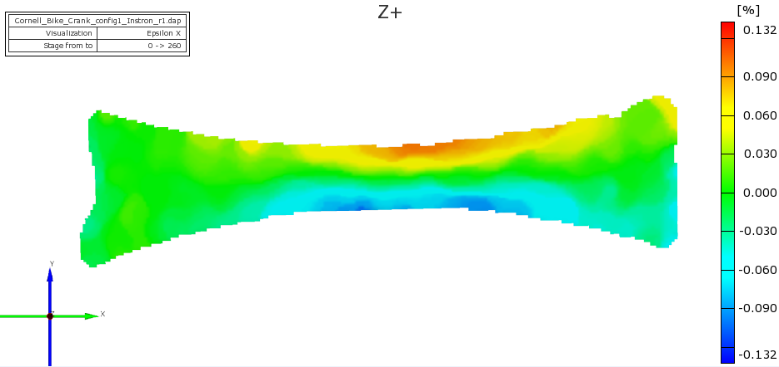

Crank 1 ARAMIS X-Strain Field, Instron Loading

Crank 1 ANSYS X-Strain Field

Crank Two:

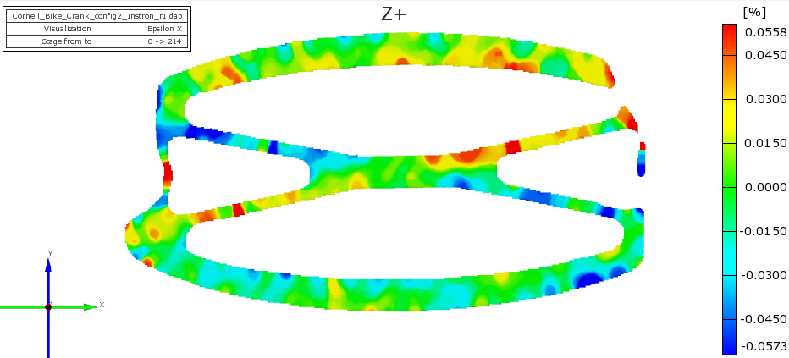

Crank 2 ARAMIS X-Strain Field, Instron Loading

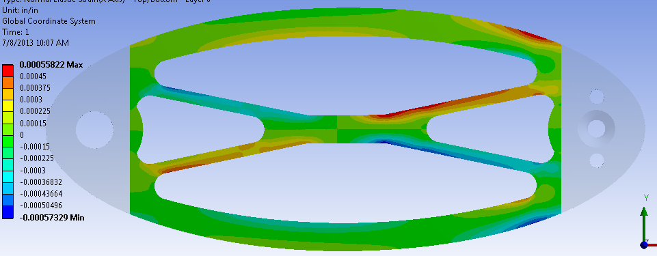

Crank 2 ANSYS X-Strain Field, Overlay
Crank Three:

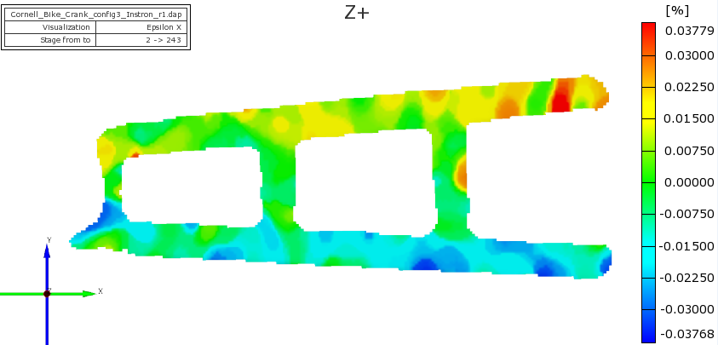

Crank 3 ARAMIS X-Strain Field, Instron Loading

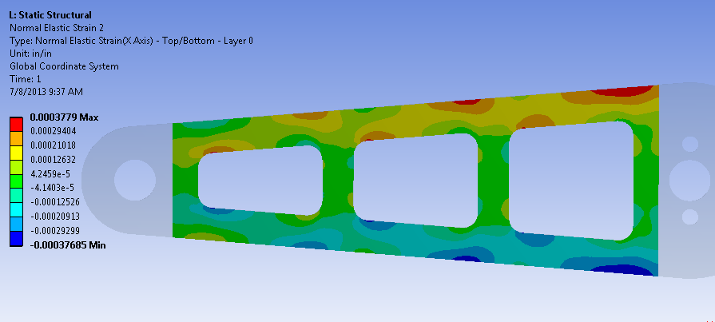

Crank 3 ANSYS X-Strain Field, Overlay

Crank Four:

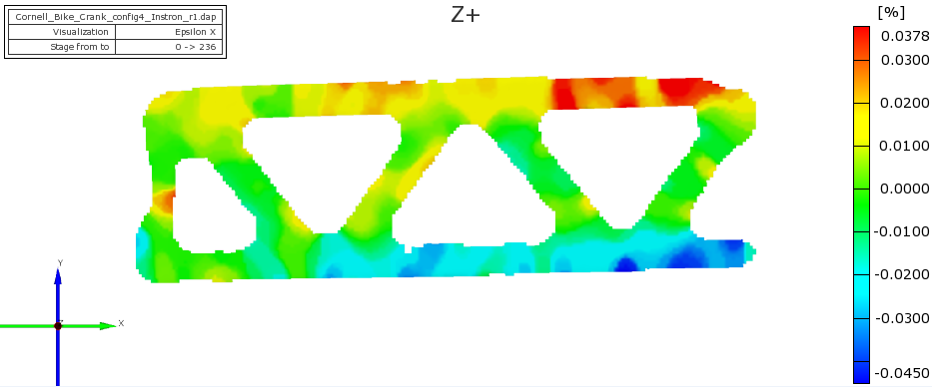

Crank 4 ARAMIS X-Strain Field, Instron Loading

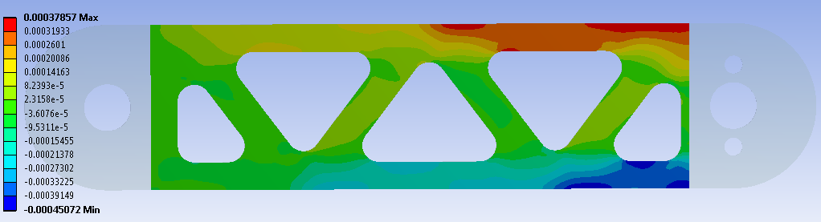

Crank 4 ANSYS X-Strain Field, Overlay

Strain Gauge Comparisons
All strain values are reported in Micro-Strain.

Area Strain Gauges on Crank 1
Strain Gauge and Direction | ANSYS | ARAMIS | Theory
Tension Gauge X | 781.64 | 932 | 789.13
Tension Gauge Y | -250.38 | -153 | -260.41
Compression Gauge X | -883.35 | -918 | -893.42
Compression Gauge Y | 280.38 | 188 | 294.83

Percent Differences of Area Strain Gauges on Crank 1
Strain Gauge and Direction | ANSYS vs. Theory | ARAMIS vs. Theory | ANSYS vs. ARAMIS
Tension Gauge X | -.949% | 18.1% | -16.1%
Tension Gauge Y | 3.85% | -41.2% | 63.6%
Compression Gauge X | -1.13% | 2.75% | -3.77%
Compression Gauge Y | -4.9% | 35.7% | 49.1%

Line Strain Gauges on Crank 1
Strain Gauge and Direction | ANSYS | ARAMIS | Theory
Tension Gauge X | 841 | 1060 | 913
Tension Gauge Y | -270 | -147 | -301
Compression Gauge X | -815 | -727 | -887
Compression Gauge Y | 262 | 178 | 293

Percent Differences of Line Strain Gauges on Crank 1
Strain Gauge and Direction | ANSYS vs. Theory | ARAMIS vs. Theory | ANSYS vs. ARAMIS
Tension Gauge X | -7.89% | 16.1% | -20.7%
Tension Gauge Y | -10.3% | -51.2% | 83.7%
Compression Gauge X | -8.12% | -18.0% | 12.1%
Compression Gauge Y | -10.6% | -39.2% | 47.2%

Crank 4 Area Strain Gauge
Strain Gauge and Direction | ANSYS | ARAMIS | Theory
Gauge 1 X | 292 | 270 | 261.6
Gauge 1 Y | -92.0 | -209 | -86.3

Percent Differences of Crank 4 Area Strain Gauge
Strain Gauge and Direction | ANSYS vs. Theory | ARAMIS vs. Theory | ANSYS vs. ARAMIS
Gauge 1 X | 11.7% | 3.21% | 8.28%
Gauge 1 Y | 5.78% | 142% | -56.0%

Secondary Procedure Analysis
ANSYS Pin Loading Simulation
The X-Strain fields given by ANSYS Workbench for a loading on the face of the hole are essentially the same as the fields given from the simulations where the force is applied through the pin. The largest percent difference in the maximum or minimum values was 6.00%, and the pin loading did not resolve the issue of the compression on the top edge of crank three; therefore, it was not necessary to continue to use the pin loading simulations.

ARAMIS with Instron Loading and ANSYS with Overlay
The ARAMIS X-Strain fields analyzed with the Instron show significantly greater areas of strain concentration than those loaded with the turn-buckle and there is also a reduction in the amount of noise. The ANSYS strain concentrations throughout the rest of the crank are much more evident with the elimination of the holes for fixing or loading the crank. The strain fields from ANSYS and ARAMIS match very well in both the pattern of the contours, areas of concentration, and values at concentrated regions for all four cranks.

The ANSYS strain fields show smoother transitions between areas of high and low strain magnitudes, but because ARAMIS is experimental data and ANSYS gives the idealized case, these differences are expected.

Looking closer at the ARAMIS X-Strain field for Crank three, there is a small region of compression at the same position as is predicted by ANSYS. This compression is not an error caused by inaccurate boundary conditions, but was not discernable in the previous ARAMIS strain fields due to the smoothing. The precision of the Instron without the displacements in the Z-direction allow this phenomenon to be seen.

Strain Gauges
Consistently throughout every strain gauge experiment, the x-strain values given by ANSYS match both the ARAMIS and theory values very well. The percent differences were typically under ten percent when comparing the ANSYS strains to the theory, and they were under twenty percent when comparing ANSYS to the ARAMIS strains. When taking into account experimental noise and imperfections, the differences in the results are not significant.

Looking specifically at crank one and measurement of x-strains, the direction of measurement runs almost parallel to the contour banding and perpendicular to the gradient of the strain field. Essentially, the x-strains measure along the direction with the lowest rate of change in the strain field. Due to this, small differences in the strain fields between ARAMIS and ANSYS will not affect the value given by the gauge as much, and also a small difference in the position of the gauge will not appear to change the value of the strain.

The Y-Strain values were not as consistent across ANSYS, ARAMIS, and the theoretical analyses, but they did follow a specific pattern for all of the gauges on crank one. The ANSYS Y-Strains were consistently around 100 micro-strain greater than the ARAMIS values; however, the theoretical strains were also greater than the ARAMIS values by 100 micro-strain and agreed closely with the ANSYS strains.

Looking at the values of the Y-Strains in relation to the X-Strains, it was discovered that in crank one the ratio of Y-Strain to X-Strain, the Poisson's Ratio, was about .2 for the ARAMIS gauges. ANSYS Workbench's strain ratio was .32 for each gauge which is fairly consistent with the Poisson's Ratio of .34 supplied to the program. It is possible that the Poisson's Ratio of the crank is not .34. A Poisson's Ratio of .2 is low for an aluminum material, but the crank is not made of perfectly ideal Al 6061 T6, and machining can affect material behavior. This possibility is explored later.

Another factor to consider when comparing the Y-Strain values is the Y-strain field. The strain field shows the same pattern of contours as in the X-direction, with the difference being that the top of the crank shows compression while the bottom shows tension. When measuring Y-Strain, the direction of measurement runs along the gradient of the strain field. This means that there are much larger changes in the strain field across the length of the gauge than when measuring x-strain. Any discrepancies between the ANSYS and ARAMIS strain fields will greatly effect the gauge value. It becomes important to position the gauges as precisely as possible so that the difference in gauge values is not due to a slight difference in position.

Y-Strain fields from the ARAMIS and ANSYS tests are shown in Appendix D. The fields of crank one are similar in the shape of the contour banding but the ARAMIS shows lower magnitudes of strains throughout the field, thus explaining the strain gauge value discrepancies. The reason for this difference is believed to be due to a Poisson's Ratio that is lower than .34. Further analysis of this possibility will be done.

The strain gauge on crank four also has a discrepancy in the Y-Strain value. The Y-Strains given by ANSYS and the theoretical calculations are significantly lower than the strain value given by ARAMIS. Looking at the Y-Strain field, in Appendix C, there is a region of high compressive strain directly where the strain gauge was placed. Although the compression matches the pattern expected by the field, the high magnitude appears to be an anomaly caused by noise in the ARAMIS.

Other
Even though the use of the Instron greatly reduced the movement in the Z-direction, there was still some displacement due to the set up of the frame. It was also noticed that the frame did not remain static when the load was applied. The frame deformed and slanted as the Instron applied the force. This movement may have caused differences in the strain fields and strain gauge values because the frame was supporting some of the one-hundred pound load.

It was also noticed that crank one does not have the same geometry as is specified in the drawing and CAD model supplied by Cornell University. The pedal end of the crank does not have a smooth transition between the rounded end and the curved middle section. Also, the crank is about one millimeter less in height throughout the middle section of the crank. These geometric differences contribute to inconsistencies between the experimental strain throughout the crank from the values that ANSYS predicts.

Regarding the y-strain fields, the y-strain values should be around one-third the magnitude of the x-strains. This reduction in magnitude makes measurements of the strains more sensitive to error. Also, the ARAMIS tracks the layer of spray paint on the face of the crank, so although most of the strains recorded by the ARAMIS are strains from the metal deforming, some may be due to movements of the paint on the surface. Especially with the y-strains, small deviations in the strain field due to the painted surface could change the amount of strain that is seen by the ARAMIS.

Tertiary Procedure: Effect of Changing Poisson's Ratio
To test to see how much the Piosson's Ratio effected the ANSYS simulation, the ANSYS model of bicycle crank one was changed to have various different Poisson's Ratios, ranging from v =.25 down to v = .18. For each Poisson's Ratio, the new X and Y strain fields were compared to the ARAMIS strain fields, and the new strain values from the 2mm x 2mm strain gauges used previously were recorded.

From the previously used area gauge on the ARAMIS, the two ratios of .205 and .18 were calculated from epsilon_y/ epsilon_x. These two Poisson's Ratio's were specifically tested, along with higher ratios.

New theoretical strain gauge values were also calculated for each change in the Poisson's Ratio.

Tertiary Procedure Results
Strain fields in the X direction remained the same as with v = .34. Y-Strain fields changed in the range of values, but the contours remained the same. The strain fields can be viewed in Appendix E.
All strain values are reported in Micro-Strain

Strain Gauge Results for v = .25
 | Old ANSYS Value (v = .34) | New ANSYS Value | ARAMIS Value | Theory Value at  v = .25
Gauge 3 X  Y | 781.64 | 782.9 | 932 | 789.13
Gauge 3 X  Y | -250.38 | -187.94 | -153 | -197.28
Gauge 4 X  Y | -883.35 | -884.78 | -918 | -893.42
Gauge 4 X  Y | 250.38 | 209.5 | 188 | 223.355

 | Old ANSYS Value (v = .34) | New ANSYS Value | ARAMIS Value | Theory Value at  v = .23
Gauge 3 X  Y | 781.64 | 783.22 | 932 | 789.13
Gauge 3 X  Y | -250.38 | -172.32 | -153 | -181.50
Gauge 4 X  Y | -883.35 | -885.14 | -918 | -893.42
Gauge 4 X  Y | 250.38 | 191.77 | 188 | 205.49
Strain Gauge Results for v = .23

Strain Gauge Results for v = .205
 | Old ANSYS Value (v = .34) | New ANSYS Value | ARAMIS Value | Theory Value at  v = .205
Gauge 3 X  Y | 781.64 | 783.62 | 932 | 789.13
Gauge 3 X  Y | -250.38 | -152.79 | -153 | -161.77
Gauge 4 X  Y | -883.35 | -885.58 | -918 | -893.42
Gauge 4 X  Y | 250.38 | 169.6 | 188 | 183.15

 | Old ANSYS Value (v = .34) | New ANSYS Value | ARAMIS Value | Theory Value at  v = .18
Gauge 3 X  Y | 781.64 | 784.01 | 932 | 789.13
Gauge 3 X  Y | -250.38 | -133.25 | -153 | -142.04
Gauge 4 X  Y | -883.35 | -886.03 | -918 | -893.42
Gauge 4 X  Y | 250.38 | 147.42 | 188 | 160.82
Strain Gauge Results for v = .18

Tertiary Procedure Analysis
The results show that as the Poisson's Ratio is decreased towards .205, the ANSYS Y-Strain values and theoretical values become closer to the ARAMIS values which were measured. After .205, when .18 was used, the strain values decrease slightly below the ARAMIS values.

This pattern leads to the belief that the Poisson's Ratio of crank one may be closer to .2 than it is to .34. This hypothesis will be tested by machining a tensile bar from crank one, and testing it for its material properties.

Conclusion
The X-strain values are larger in magnitude than the Y-Strain values, so they are of more interest than the Y-strains. The X-Strain fields from ARAMIS and ANSYS and the X-strain gauge values consistently matched across the experiments and simulations run. ANSYS was consistently able to predict the regions of high strain concentration on the cranks and produce a reasonably accurate value of strain in this region. This ability is important because it enables the user to see where in a loaded structure the material has the greatest risk of failure. The strain gauging in ANSYS also yielded accurate results. The X-Strains were consistently within twenty-percent of the ARAMIS and theoretical values, and were often better than that.

Although the Y-Strain values given by ANSYS were consistently higher than the measured ARAMIS values, ANSYS still outputs values which match with the theoretical calculations. It seems that the discrepancy in Y-Strains is the result of an unusually low Poisson's Ratio in the crank. This hypothesis will be tested later. Given a lower Poisson's Ratio, the ANSYS values begin to match the ARAMIS data very well.

Appendices
A. Crank Geometry Drawings
A.1 Crank One Drawing
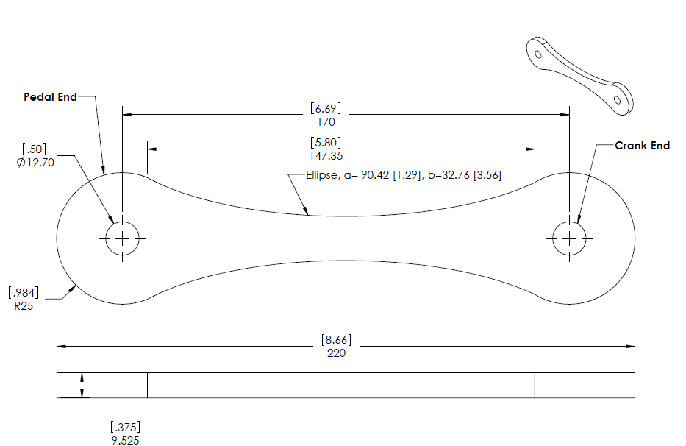

A.2 Crank Two Drawing

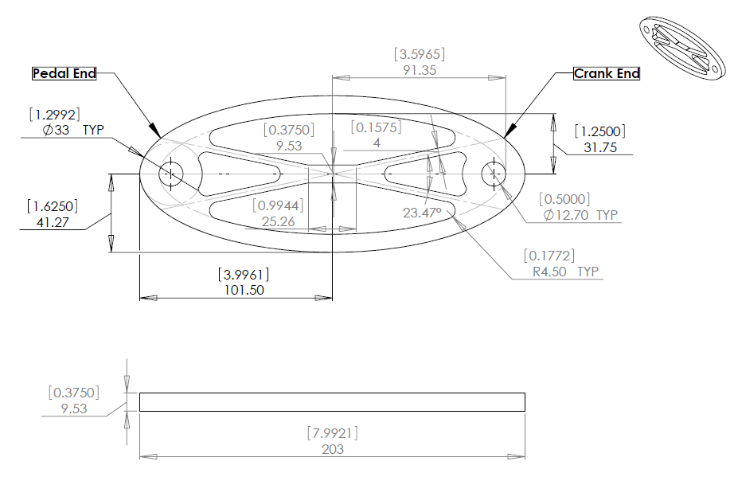

A.3 Crank Three Drawing
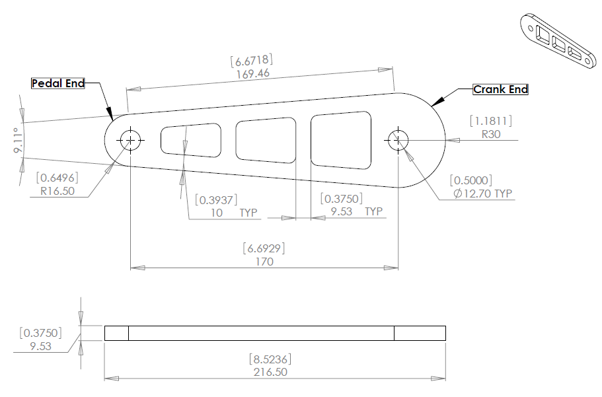

A.4 Crank Four Drawing
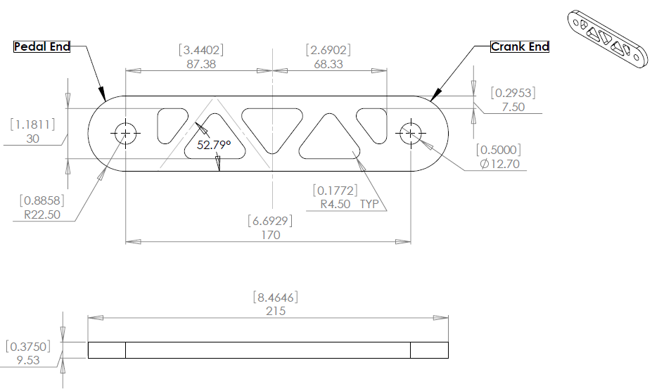

B. Placement of Strain Gauges
B.1 Area Gauges on Crank 1
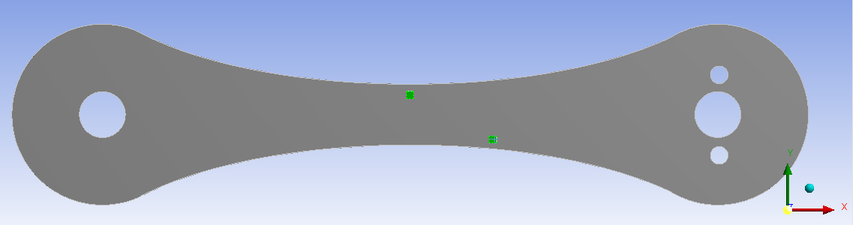

B.2 Area Gauge on Crank 4
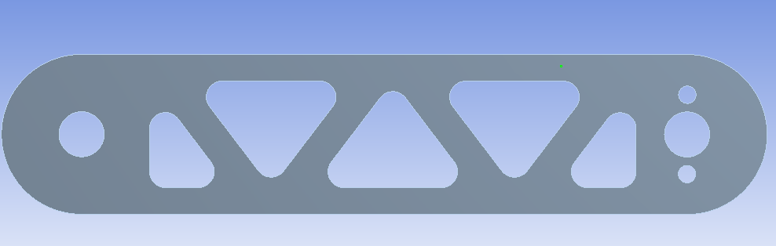

C. X-Strain Fields of ANSYS Pin Loading
C.1 Crank One, Pin Loading
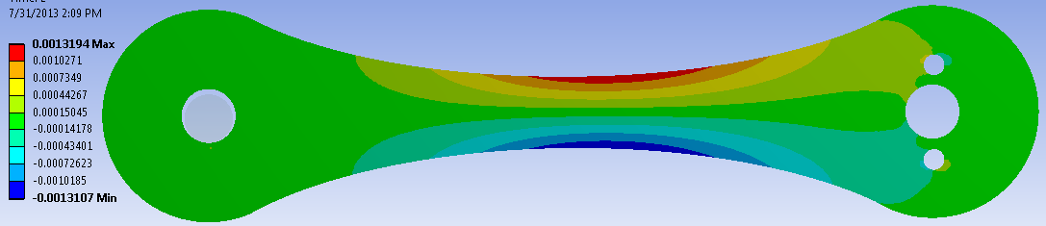

C.2 Crank Two, Pin Loading
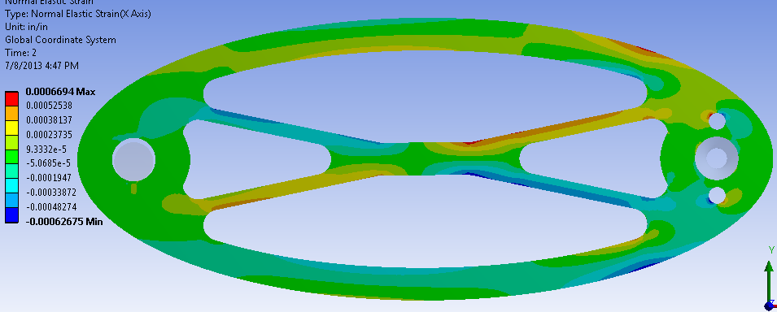

C.3 Crank Three, Pin Loading
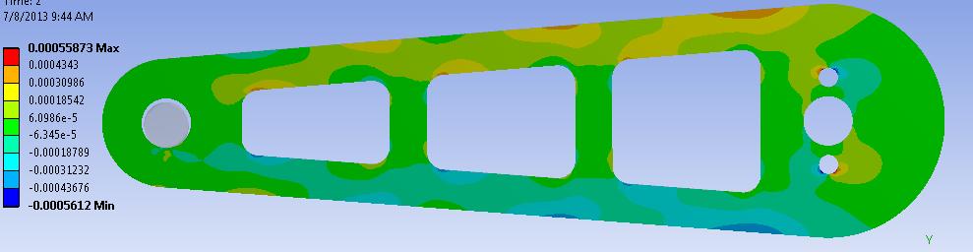

C.4 Crank Four, Pin Loading
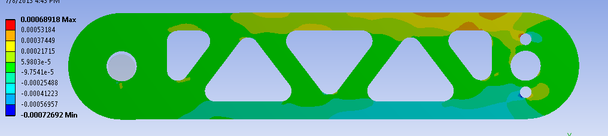

D. Y-Strain Fields
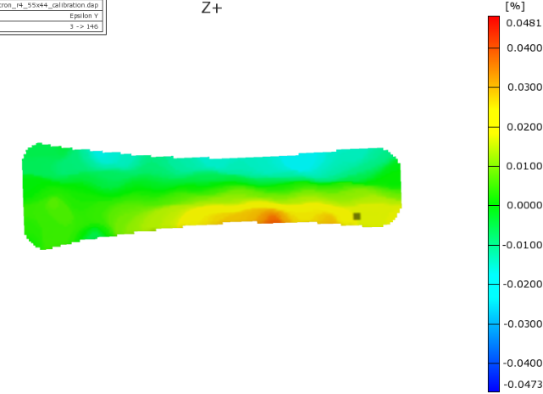
D.1 Crank One Y-Strain Field
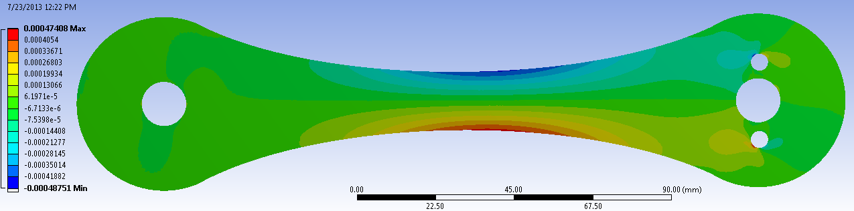

ARAMIS

ANSYS

D.2 Crank 2 Y-Strain Fields
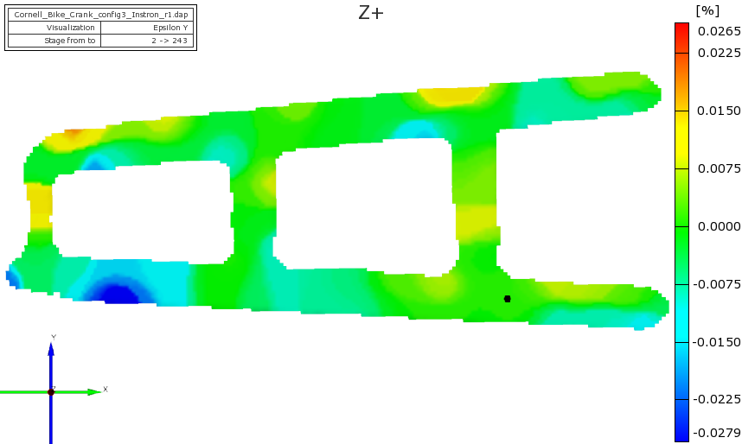

ARAMIS

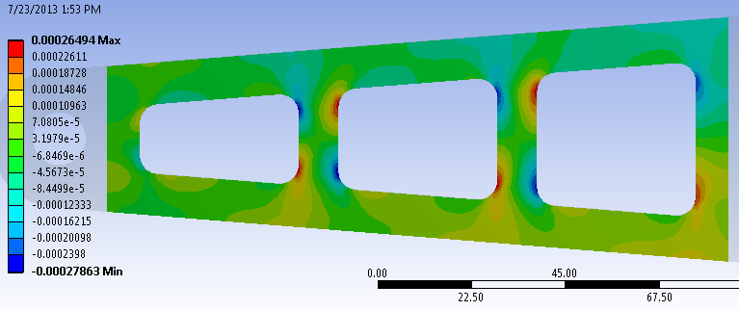

ANSYS

D.3 Crank 3 Y-Strain Fields
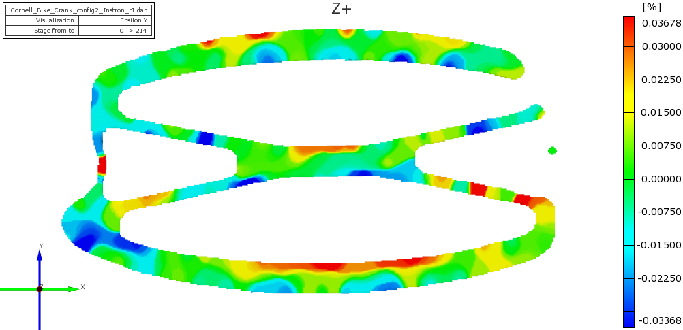

ARAMIS

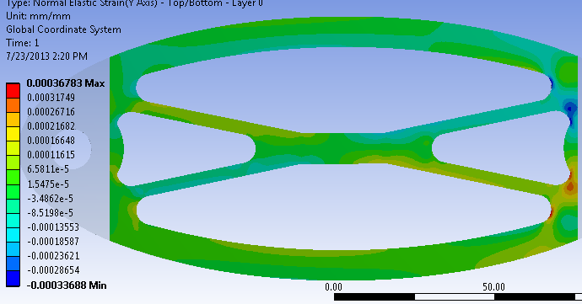

ANSYS

D.4 Crank 4 Y-Strain Fields
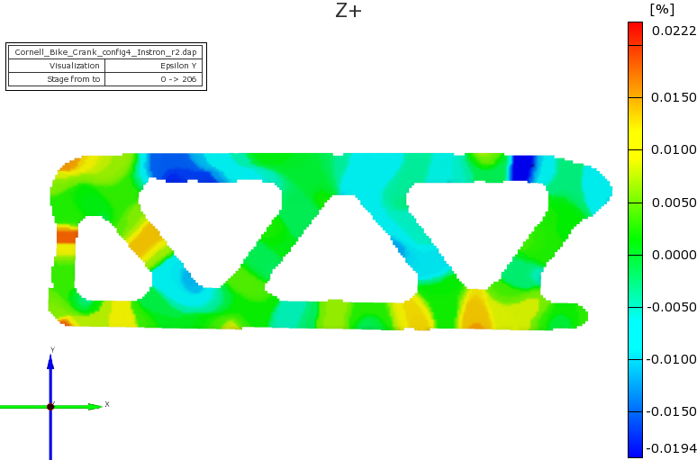

ARAMIS

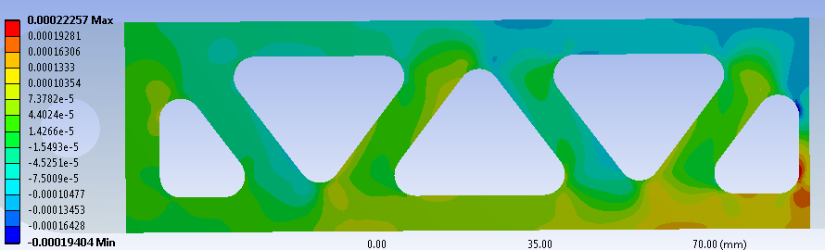

ANSYS

E. ANSYS Strain Fields of Crank one with Changing Poisson's Ratio
E.1 v = .25
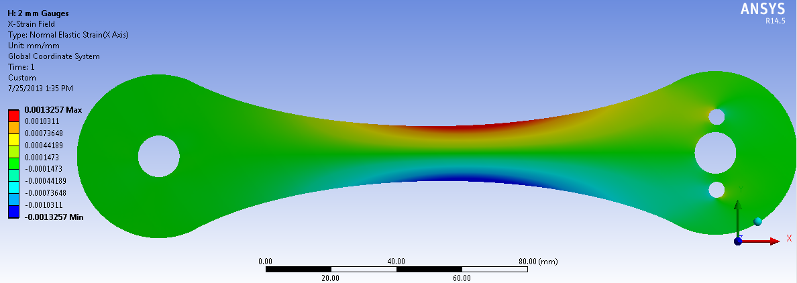

X-Strain Field at v = .25

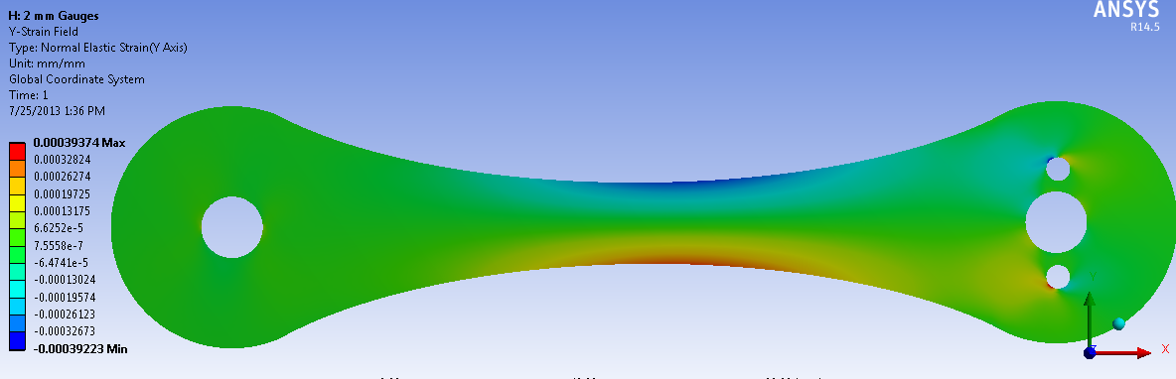

Y-Strain Field at v = .25

E.2 v = .23

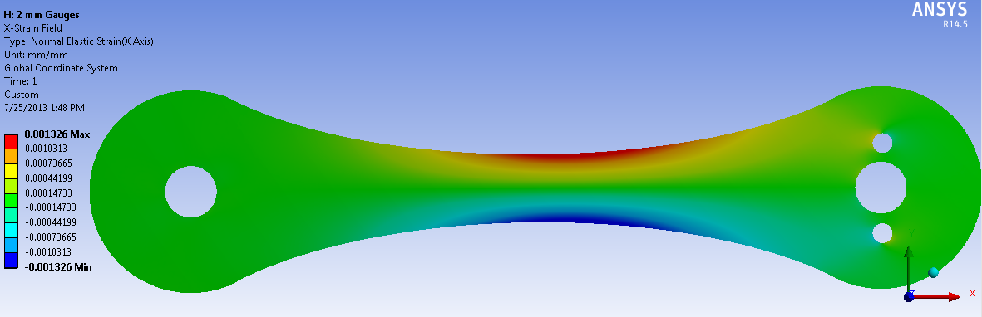

X-Strain Field at v = .23

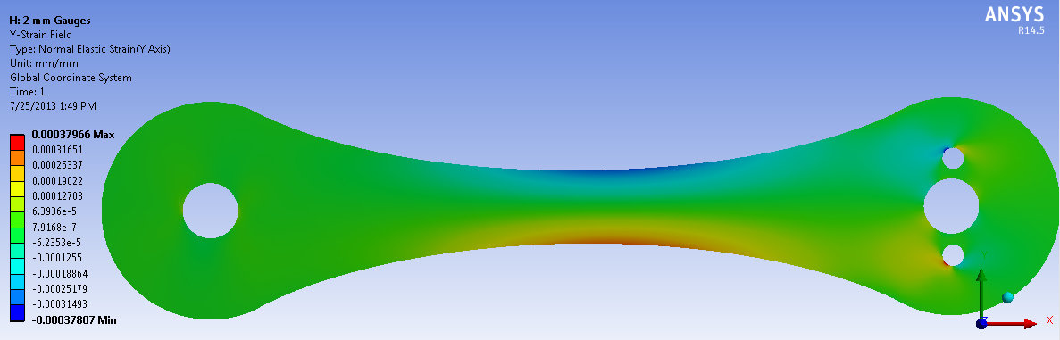

Y-Strain Field at v = .23

E.3 v = .205
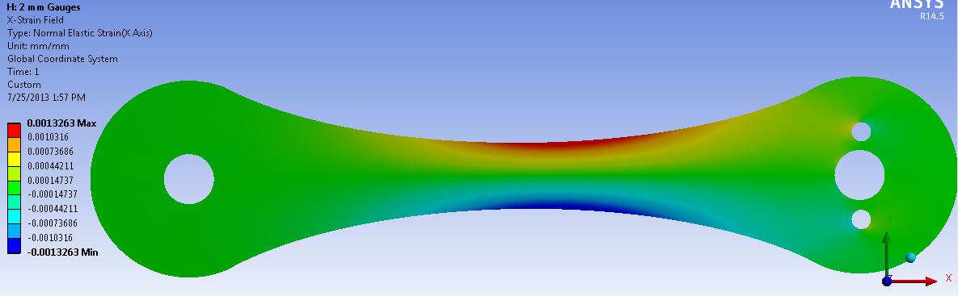

X-Strain Field at v = .205

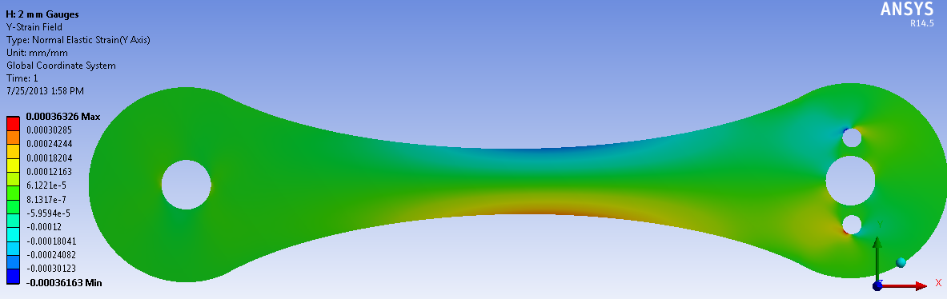

Y-Strain Field at v = .205

E.4 v = .18

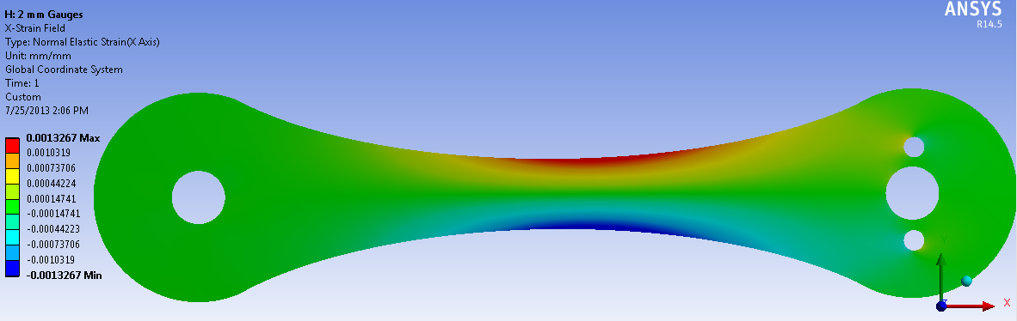

X-Strain Field at v = .18

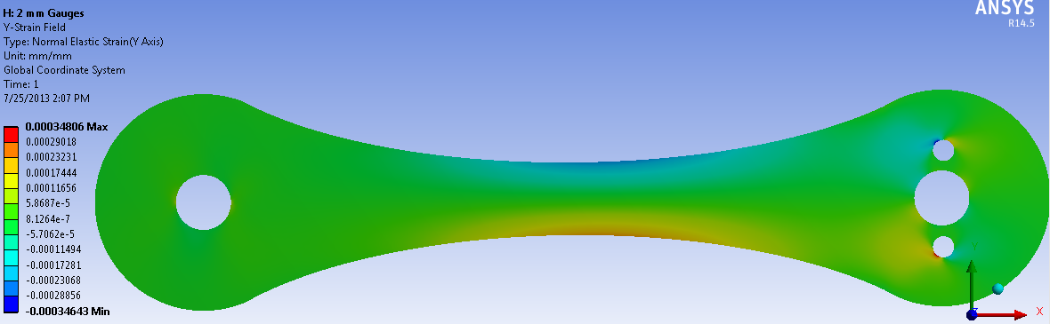

Y-Strain Field at v = .18

